**Keishinin Temple**

Keishinin is a Nichiren Buddhist temple located near the summit of Mt. Shichimen, a mountain known for its natural beauty and the history and mythology associated with it. The climb up the mountain to Keishinin takes an average of three to four hours. On cloudy days, mist covers the mountain, casting a mystical mood over the trail to the temple.

Facing east at an altitude of 1,740 meters, Keishinin has a commanding view of Mt. Fuji. During the spring and autumnal equinox, the natural phenomenon known as Diamond Fuji can be observed here. When the sun rises directly behind Mt. Fuji, the peak appears to sparkle like a diamond when the sun reaches the top of the mountain.

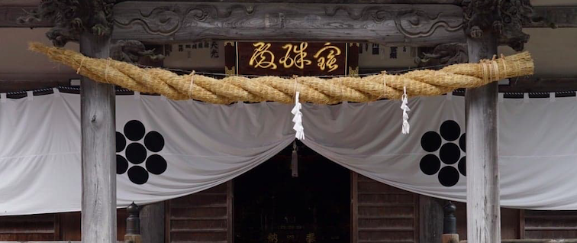

*Blend of Shinto and Buddhist Traditions*

Before Nichiren’s followers built Keishinin Temple, Mt. Shichimen was considered sacred according to Shinto traditions. As a result, Keishinin provides visitors a chance to see how Buddhist and Shinto traditions blend together, as seen in religious rites, architecture, and the ornamentation of the temple.

One prominent example are the *shimenawa* ropes hung at various gates and entrances to the temple. *Shimenawa* were traditionally used in Shinto purification rituals, and are used here to bring luck and ward off evil spirits. *Shimenawa* are often hung to mark an area or building, such as Keishinin Temple, as a sacred place, and they are hung, for example, for ceremonies marking the construction of a new building.

*Experience Life in the Temple*

Keishinin is an important temple for Nichiren sect followers. Many monks and lay followers make the trip up the mountain regularly to practice their faith, and the temple has lodgings available for those who want to stay overnight to attend an early morning service or witness the sunrise over Mt. Fuji. With overnight accommodations open to anyone with a reservation, Keishinin may be an essential experience for Nichiren sect followers and non-followers alike.

Regardless of religious background, visitors are welcome to live a day at the temple as would a monk. The Keishinin rooms, dinner and breakfast service, bathing and toilet facilities are basic, and the meals are vegetarian.

Keishinin visitors can also take part in a Nichiren Buddhist service.

*Nearby Landmarks*

Behind Keishinin is Ichinoike Pond, where the fabled Shichimen Daimyojin Dragon Goddess is said to have lived. People claim that on certain occasions they have seen ripples in the pond, as if a dragon were moving below the surface.

From Ichinoike Pond, walk 15–20 minutes to Ninoike Pond, where Okunoin Temple is located. The boulder where a few of Nichiren’s disciples saw the Dragon Goddess, known as Yogo Seki, is here as well.