**Life in Tsuta through the Brush of Omachi Keigetsu**

Omachi was a prolific creator, and a small museum in Tsuta Onsen houses many of his works—folding screens and scrolls of his calligraphy, travel diaries, poems, and other materials. During his time in Tsuta, he would frequently sketch scenes of the lives of local residents, himself included. A collection of these has been published in two small, hand-bound books printed on traditional Japanese paper: the *Book of Winter* and the *Book of Tsuta Hot Spring*. They showcase his humorous and deeply perceptive gaze in brief, simple brushstrokes. Through these books, we can get glimpses of what Omachi’s life was like in the beautiful, though often harsh, environment of Tsuta a century ago. Here is a sampling of pages from the two books.

**From the *Book of Winter***

1.

文字の書かれた紙

Omachi trudging through the snow with his ever-present sketching brush and a gourd of sake.

2.

文字と絵が書かれた紙

The text describes a 13-year-old girl who talked a lot—and ate a lot, shoveling down seven bowls of rice.

3.

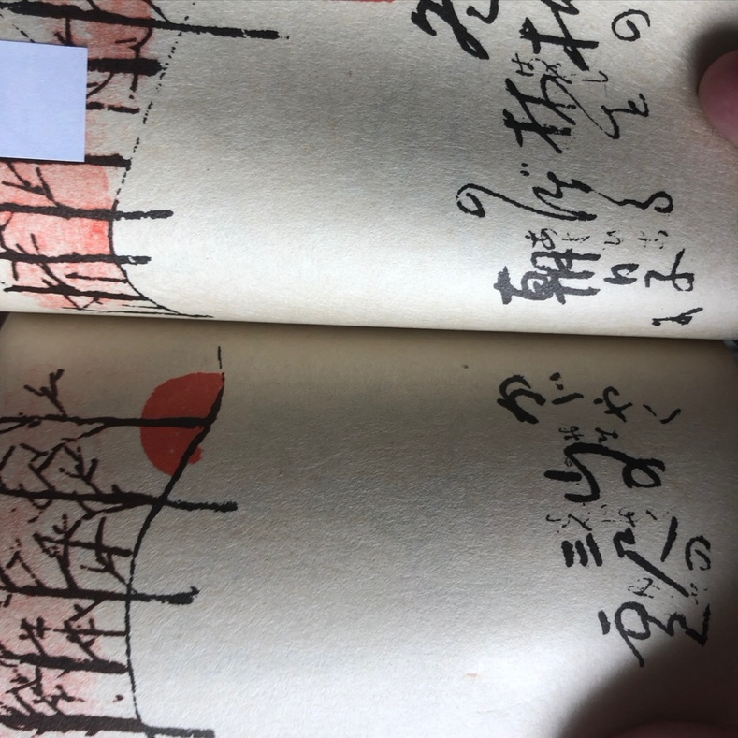

A winter scene of bare trees poking out of the snow at sunrise.

4.

The author-artist in the hot spring, under a waterfall and the winter moon.

5.

A poem about the four friends that accompanied Omachi in the mountains: something to read, materials to sketch and write with, a gourd of sake, and the moon above the snowy peaks.

6.

ホワイトボードに書かれた絵

中程度の精度で自動的に生成された説明Omachi’s sketches of the trout fry being raised at the inn at various stages of growth.

**From the *Book of Tsuta Hot Spring***

1.

文字と絵が書かれた紙

A self-portrait of the author-artist walking briskly in a field of flowers.

2.

文字と絵が書かれた紙

Walking with snowshoes in the mountains to the sound of bush warblers.

3.

Relaxing in the bath after a day of trout fishing in the swamps.

4.

A poem and sketch of *mizubasho*, or Asian skunk cabbage, which brightens the forest with its blooms in early spring.

5.

One of the author-artist’s favorite pastimes: warming up with sake in front of the *irori* hearth after a solo bath.