Captions

(Max 20 Words)
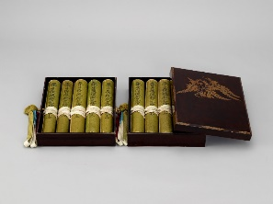
Two-tiered lacquer box that originally held the Kasuga Scrolls. The lid is decorated with wisteria flowers, the crest of the Fujiwara family.

(Max 10 Words)
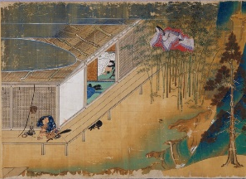
Example of Takashina Takakane’s skill in depicting architecture (scroll 1).

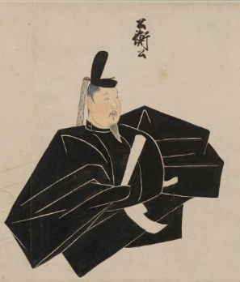
(Max 10 Words)
Portrait of Saionji Kinhira, who commissioned the Kasuga Scrolls.

What is the Kasuga Deity?
The Kasuga Deity, also known as Kasuga Daimyojin or Kasuga Gongen, refers to both the five deities of Kasuga Taisha Shrine and a single divine entity made up of the five. In their separate forms, the deities are: Takemikazuchi no Mikoto, Futsunushi no Mikoto, Ame no Koyane no Mikoto, Himegami, and Ame no Oshikumone no Mikoto. The deer that can be seen around Nara are considered to be the divine messengers of the Kasuga Deity.

2 Proposals for the Pamphlet’s Title
A Masterpiece of Devotion: Illustrated Miracles of the Kasuga Deity

Illustrated Miracles of the Kasuga Deity: A Vibrant Glimpse into the Mundane and Miraculous

